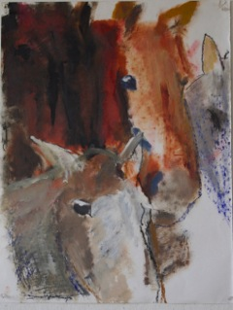
"Expectation" 18" x 24" oil on paper
You are invited to:
"T H E H O R S E S H O W"
by
B E L L A H A L S T E D
Opening: Thursday, June 2nd 5 -7:00 p.m.
Reception: Sunday, June 12th 4 -6:00 p.m.
at the
Barnes Gallery in Leverett
Friday through Sunday afternoons, 2 - 5:00 p.m.*
June 2nd – 25th, 2016
The Leverett Arts and Crafts Center
13 Montague Road, Leverett Massachusetts
*
*or by arrangement with Bella (bella@crocker.com) (413- 256-6454)

This show is dedicated to Russell Freedman

